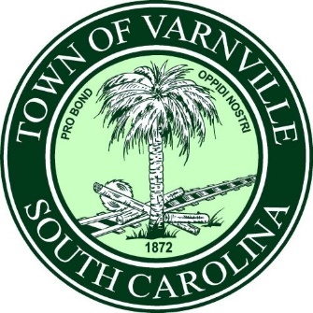
03/11/2025
PUBLIC NOTICE
The following property is deemed unsafe, unsanitary, dangerous, and detrimental to the overall health, safety, and welfare of town residents.
964 Carolina Ave. Varnville/ TM # 119-12-05-0031
Owner of Record: Nakita Orr

Pursuant to Town of Varnville Nuisance Ordinance Code #26 Article II Sec. 21-23, The Town of Varnville has enacted measures to abate the condition of said property.

